ML Assignment-3

In this assignment I have designed a HMM model for Part of Speech tagging on the Brown dataset. We use the part of speech tags as the hidden states and the tokens as the observed variable of the HMM. We code the Viterbi algorithm for the decoding problem and obtain the POS for the test data. We also report the f1 score, the precision and recall for all the POS tags.

We calculate the emission and transition probabilities in the code as follows: -

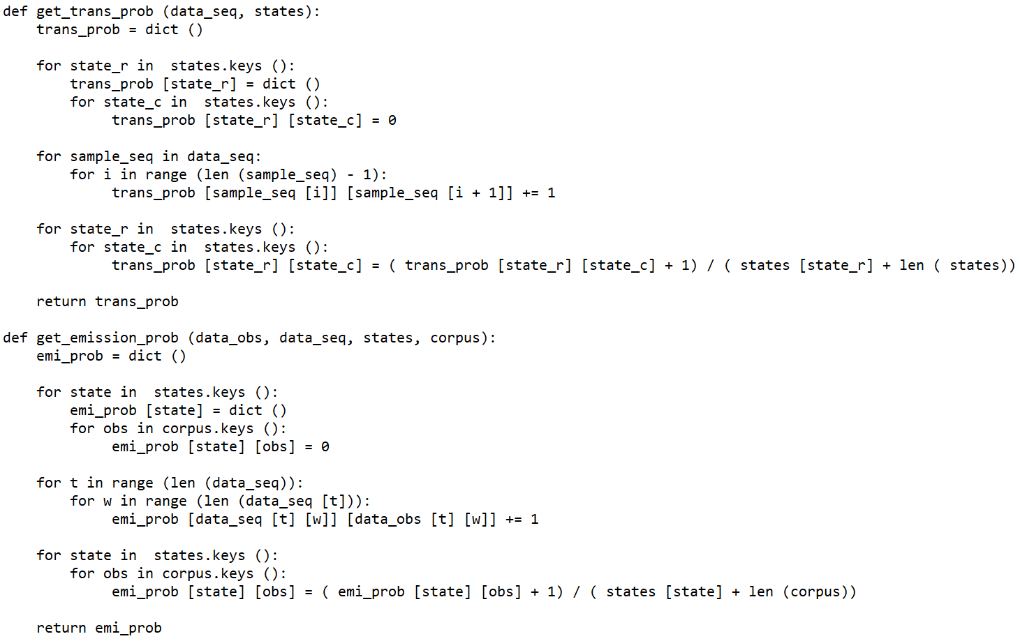

The precision, recall and F1 score for the tags are as follows: -

Tags: - PRON, VERB, DET, NOUN, ., ADJ, ADP, PRT, ADV, NUM, CONJ, X

Precision: - [0.63531353, 0.97007293, 0.90665803, 0.94966915, 0.98982751,

0.8676573 , 0.90895197, 0.92457421, 0.9146437 , 0.99219969,

0.98421808, 0.00366331]

Recall: -[0.7815095 , 0.64989329, 0.6582576 , 0.55137322, 0.62790208,

0.51233891, 0.6255917 , 0.63039151, 0.62728249, 0.47462687,

0.57857745, 0.91608392]

F1 Score: -[0.70086885, 0.77834202, 0.76274341, 0.69767803, 0.76837904,

0.64425481, 0.74110997, 0.74965476, 0.74418605, 0.64209995,

0.72875354, 0.00729744]

The overall accuracy for the POS tagging task using the bigram model is around 60%.

We also notice that in our case, using trigram model for HMM improves the accuracy to about 90%. Hence, the trigram model performs significantly better than the bigram HMM model for POS tagging. The trigram model works well as it has more words to calculate the transition probabilities.